**Project Report Format**

1. **INTRODUCTION**
   1. Project Overview
   2. Purpose
2. **LITERATURE SURVEY**
   1. Existing problem
   2. References
   3. Problem Statement Definition
3. **IDEATION & PROPOSED SOLUTION**
   1. Empathy Map Canvas
   2. Ideation & Brainstorming
4. **REQUIREMENT ANALYSIS**
   1. Functional requirement
   2. Non-Functional requirements
5. **PROJECT DESIGN**
   1. Data Flow Diagrams & User Stories
   2. Solution Architecture
6. **PROJECT PLANNING & SCHEDULING**
   1. Technical Architecture
   2. Sprint Planning & Estimation
   3. Sprint Delivery Schedule
7. **CODING & SOLUTIONING (Explain the features added in the project along with code)**
   1. Feature 1
   2. Feature 2
   3. Database Schema (if Applicable)
8. **RESULTS**
   1. Output Screenshots
9. **ADVANTAGES & DISADVANTAGES**
10. **CONCLUSION**
11. **FUTURE SCOPE 13. APPENDIX** Source Code

GitHub & Project Demo Link

1. **INTRODUCTION**
   1. **Project Overview**  
      ->The project focuses on the classification of weather phenomena using deep learning techniques. Weather classification is crucial for meteorologists and weather forecasters, impacting various aspects of daily life, environmental monitoring, and agricultural planning. The project aims to accurately categorize weather into five main types: Cloudy, Shine, Rain, Foggy, and Sunrise. It leverages the power of deep learning (DL), a subset of artificial intelligence (AI), known for its high-performance classification capabilities.
   2. **Purpose**->The purpose of the project is to enhance the prediction and communication of weather patterns by using advanced AI methodologies. Specifically, it employs transfer learning, which involves applying knowledge gained from one problem to a new but related problem. By using pre-trained models such as Inception V3, VGG19, and Xception V3, the project seeks to improve image analysis and classification of weather phenomena, which is expected to benefit environmental quality assessments and agricultural planning by providing more accurate and timely weather information.
2. **LITERATURE SURVEY**
   1. **Existing problem**

->The primary challenge in weather classification is the accurate and efficient identification of different weather phenomena. Traditional methods rely heavily on manual observation and pattern recognition by meteorologists, which can be time-consuming and subject to human error. The advent of deep learning offers a more automated and accurate approach, but it comes with its own set of challenges, including:

* Data Availability and Quality: High-quality, labeled datasets are essential for training deep-learning models. However, obtaining such datasets for different weather conditions can be challenging.
* Model Complexity and Overfitting: Deep-learning models, especially those used in transfer learning, are complex and require a significant amount of data to train. There's a risk of overfitting, where the model performs well on training data but poorly on unseen data.
* Computational Resources: Training deep-learning models is computationally intensive and requires significant resources, which might not be accessible to all researchers or meteorological organizations.
* Generalization: The ability of the model to generalize well to new, unseen data is crucial. Models trained on data from specific geographic locations or seasons may not perform well when applied to different conditions.
  1. **Problem Statement Defination**

->The problem statement in weather classification using deep learning can be defined as follows:

"Develop an efficient and accurate deep-learning-based system for classifying various weather phenomena. This system should leverage transfer learning techniques to utilize pre-trained models like Inception V3, VGG19, and Xception V3 for enhancing the classification accuracy. The model should be capable of distinguishing between at least five major weather categories: Cloudy, Shine, Rain, Foggy, and Sunrise. The ultimate goal is to create a system that can aid meteorologists and environmental scientists in accurate weather prediction and analysis, thereby contributing to various practical applications such as environmental monitoring, weather forecasting, and agricultural planning."

1. **IDEATION & PROPOSED SOLUTION**
   1. **Empathy Map Canvas**

**->**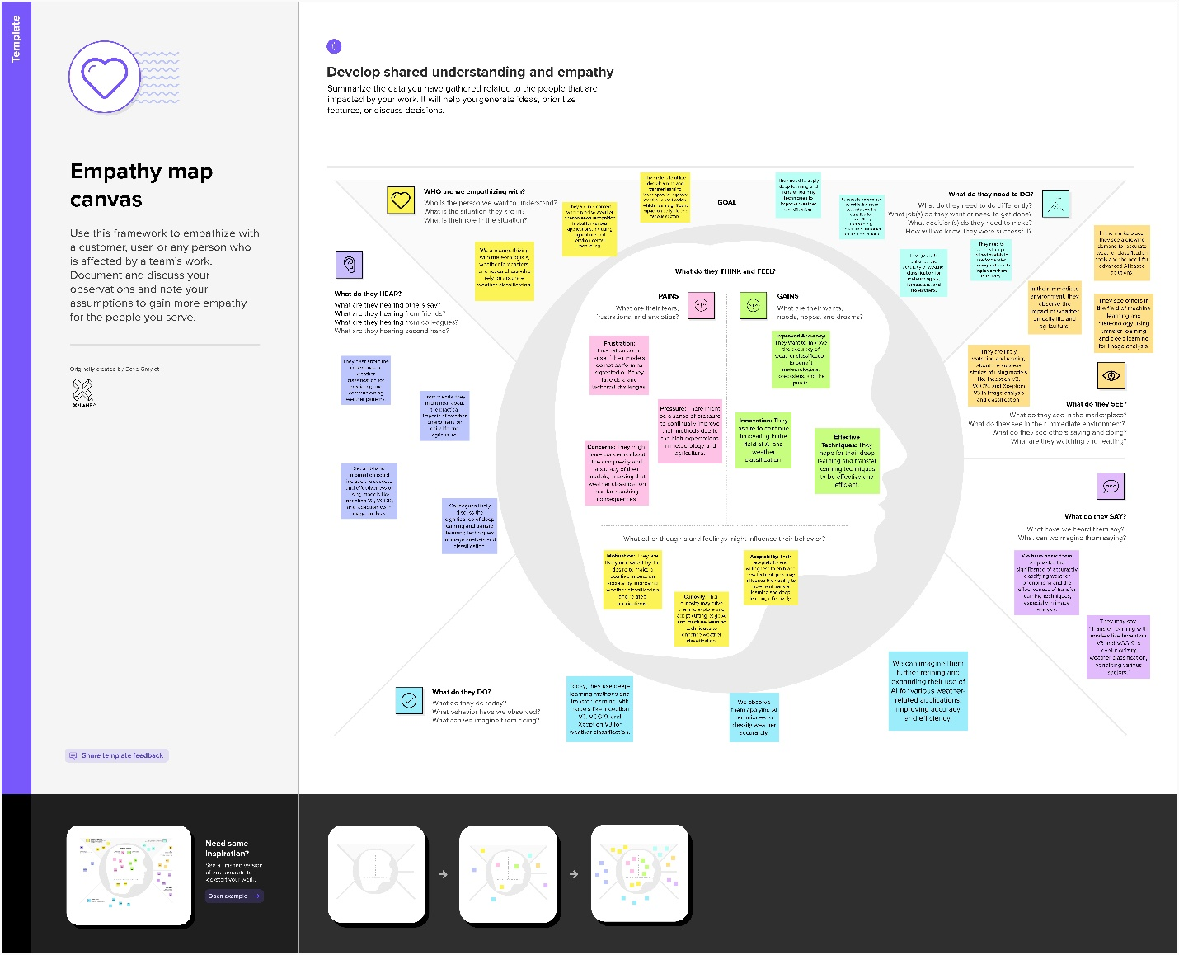

* 1. **Ideation and Brainstorming**
* 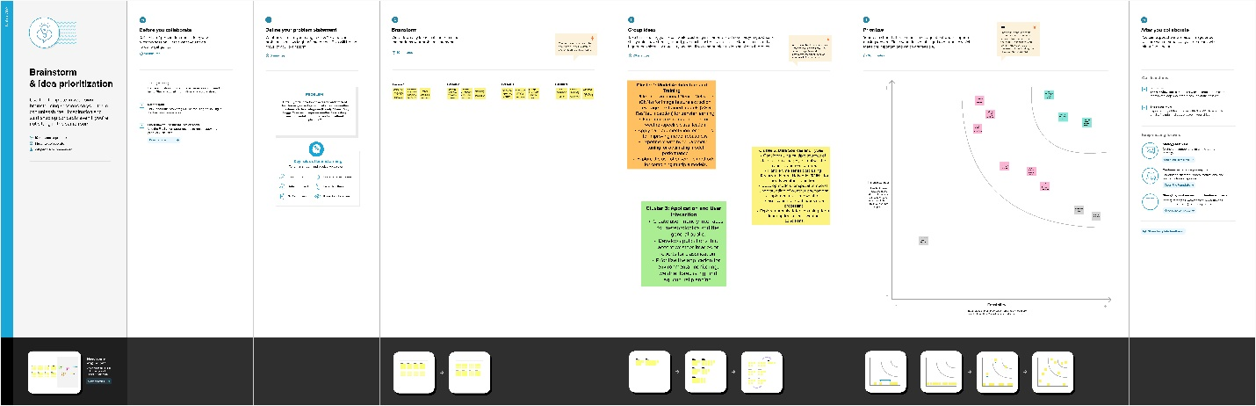

1. **Requirement Analysis**
   1. **Functional Requirements**
      1. Data Collection and Preprocessing:
         1. Capability to gather and process diverse weather images from multiple sources.
         2. Implementation of image preprocessing techniques like normalization, resizing, and augmentation.
      2. Model Training and Validation:
         1. Efficient training of deep learning models on the preprocessed dataset.
         2. Validation of model performance using a separate dataset to ensure accuracy.
      3. Weather Phenomena Classification:
         1. Accurate classification of weather into predefined categories: Cloudy, Shine, Rain, Foggy, and Sunrise.
         2. Real-time processing and classification capabilities for live data.
      4. Model Updating and Retraining:
         1. Facility to update and retrain the model with new data to improve accuracy and adapt to new patterns.
      5. User Interface and Interaction:
         1. A user-friendly interface for users to interact with the system, input data, and view classification results.
         2. Provision for users to provide feedback on classification accuracy.
      6. Integration with Forecasting Systems:
         1. Ability to integrate the classification system with existing weather forecasting systems and databases.
      7. Reporting and Visualization:
         1. Generation of reports and visualizations of classification results for easier interpretation.
   2. **Non – Functional Requirements**
      1. Performance:
         1. High accuracy and speed in classifying different weather phenomena.
         2. Efficient handling of large datasets without significant delays.
      2. Scalability:
         1. Ability to scale the system for larger datasets or more complex classification tasks.
      3. Reliability:
         1. Consistent performance under different operational conditions.
         2. Robustness against data inconsistencies and operational interruptions.
      4. Usability:
         1. Ease of use for individuals with varying levels of technical expertise.
         2. Intuitive and clear user interface and documentation.
      5. Maintainability:
         1. Easy to update and maintain the system with minimal downtime.
         2. Flexibility in integrating new features or improvements.
      6. Security:
         1. Protection of sensitive data and adherence to data privacy regulations.
         2. Secure access controls to prevent unauthorized usage.
      7. Portability:
         1. Compatibility with different platforms and devices, facilitating widespread use.
      8. Resource Efficiency:
         1. Optimal use of computational resources, balancing performance and resource consumption.
2. Project Design
   1. Data Flow Diagram and User Stories

->-> **Data Flow Diagram (Level 0)**

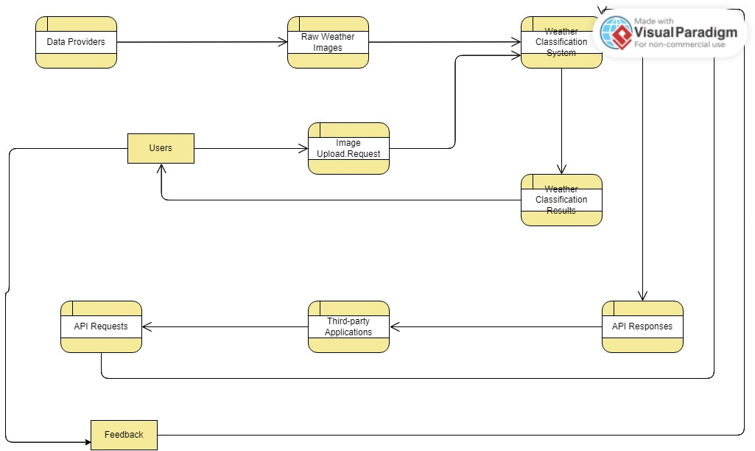

-> **User Stories**

Use the below template to list all the user stories for the product.

|  |  |  |  |  |  |  |
| --- | --- | --- | --- | --- | --- | --- |
| **User Type** | **Functional**  **Requirement (Epic)** | **User**  **Story**  **Number** | **User Story / Task** | **Acceptance criteria** | **Priority** | **Release** |
| User  (Meteorologist) | Image Upload | USN-1 | As a user, I can upload a weather image to the system. | The image is successfully uploaded and ready for analysis. | High | Sprint-1 |
| User  (Meteorologist) | Weather Classification | USN-2 | As a user, after uploading, I want to get the weather classification of the image. | The system provides accurate weather type classification (e.g., Cloudy, Shine, Rain, etc.). | High | Sprint-1 |
| User (General  Public) | View Weather Types | USN-3 | As a user, I can view different weather classifications on the dashboard. | I can see a list or grid  of weather classifications with representative images. | Medium | Sprint-2 |
| User (General  Public) | Feedback | USN-4 | As a user, I can provide feedback if the classification seems incorrect. | The system acknowledges my feedback for further model refinement. | Medium | Sprint-2 |
| Third-party  Developer | API Access | USN-5 | As a third-party developer, I can access the weather classification via an API. | I can send an image and receive a classification response. | High | Sprint-1 |
| Administrator | System Monitoring | USN-6 | As an administrator, I can monitor the number of images processed and the feedback received. | I can view analytics and feedback data on an admin dashboard. | High | Sprint-1 |
| Administrator | User Management | USN-7 | As an administrator, I can manage user roles and access. | I can add, modify, or remove user roles and permissions. | Medium | Sprint-2 |

* 1. Solution Architecture

-> **Solution Architecture Diagram:**

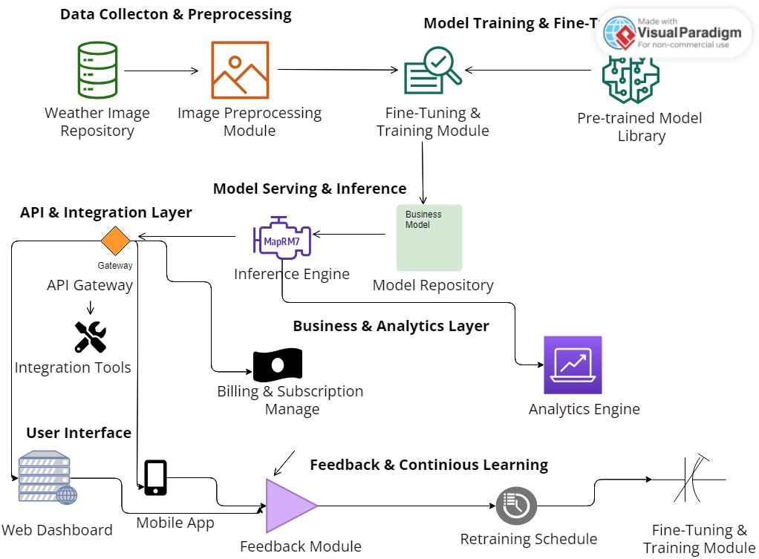

*Figure 1: Weather Classification System: Solution Architecture*

1. Project Planning and Scheduling

-> Use the below template to create product backlog and sprint schedule

|  |  |  |  |  |  |  |
| --- | --- | --- | --- | --- | --- | --- |
| **Sprint** | **Functional**  **Requirement (Epic)** | **User Story**  **Number** | **User Story / Task** | **Story Points** | **Priority** | **Team**  **Members** |
| Sprint-1 | Registration | USN-1 | As a user, I can register for the application by entering my email, password, and confirming my password. | 2 | High | Sumit,Lakshay |
| Sprint-1 | Registration | USN-2 | As a user, I will receive confirmation email once I have registered for the application | 1 | High | Sumit,Lakshay |
| Sprint-2 | Registration | USN-3 | As a user, I can register for the application through Facebook | 2 | Low | Sumit,Lakshay |
| Sprint-1 | Registration | USN-4 | As a user, I can register for the application through Gmail | 2 | Medium | Sumit,Lakshay |
| Sprint-1 | Login | USN-5 | As a user, I can log into the application by entering email & password | 1 | High | Yash,  Mritunjay |
| Sprint-2 | Dashboard | USN-6 | As a user, after logging in, I can view a dashboard with my user details. | 3 | High | Yash,  Mritunjay |
| Sprint-2 | Dashboard | USN-7 | As a user, on the dashboard, I can view my activity history. | 2 | High | Yash,  Mritunjay |
| Sprint-3 | Dashboard | USN-8 | As a user, I can customize the layout of my dashboard. | 3 | Medium | Yash,  Mritunjay |

**Project Tracker, Velocity & Burndown Chart: (4 Marks)**

|  |  |  |  |  |  |  |
| --- | --- | --- | --- | --- | --- | --- |
| **Sprint** | **Total Story Points** | **Duration** | **Sprint Start Date** | **Sprint End Date (Planned)** | **Story Points**  **Completed (as on**  **Planned End Date)** | **Sprint Release Date (Actual)** |
| Sprint-1 | 20 | 6 Days | 24 Oct 2023 | 29 Oct 2023 | 20 | 29 Oct 2023 |
| Sprint-2 | 20 | 6 Days | 31 Oct 2023 | 05 Nov 2023 |  |  |
| Sprint-3 | 20 | 6 Days | 07 Nov 2023 | 12 Nov 2023 |  |  |
| Sprint-4 | 20 | 6 Days | 14 Nov 2023 | 19 Nov 2023 |  |  |
|  |  |  |  |  |  |  |
|  |  |  |  |  |  |  |
|  |  |  |  |  |  |  |
|  |  |  |  |  |  |  |

**Velocity:**

Imagine we have a 10-day sprint duration, and the velocity of the team is 20 (points per sprint). Let’s calculate the team’s average velocity (AV) per iteration unit (story points per day)

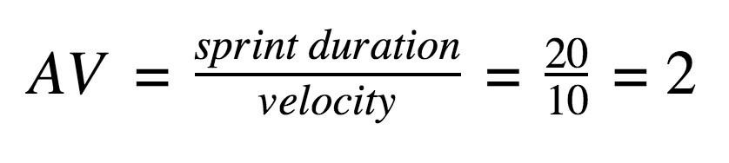

**Burndown Chart:**

A burn down chart is a graphical representation of work left to do versus time. It is often used in agile [software development m](https://www.visual-paradigm.com/scrum/what-is-agile-software-development/)ethodologies such as [Scrum.](https://www.visual-paradigm.com/scrum/scrum-in-3-minutes/) However, burn down charts can be applied to any project containing measurable progress over time.

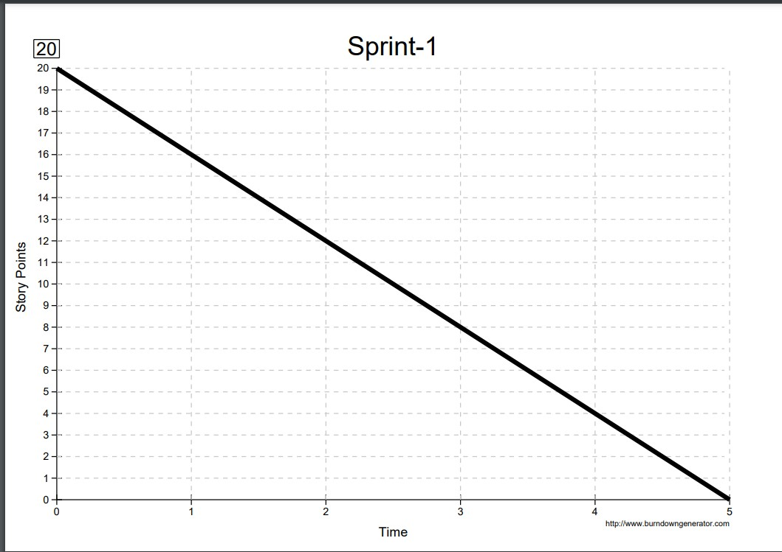

1. Coding and Solutioning

let predic_result =""

function imgUp() {

// Get the file from the file input

console.log("Called imgUp")

var fileInput = document.getElementById('file');

var file = fileInput.files[0];

// Check if a file was selected

if (!file) {

console.log("No file selected!");

return;

}

// Create a FormData object and append the file to it

var formData = new FormData();

formData.append('image', file); // The 'image' key should match the name in your Flask route

// Perform the fetch request to the Flask server

fetch("http://127.0.0.1:5000/predict", {

method: "POST",

body: formData

})

.then(response => response.text()) // Assuming the server responds with text (change this if JSON response)

.then(data => {

predic_result = data

output()

})

.catch(error => console.error('Error:', error));

}

function output(){

window.location.href = `http://127.0.0.1:5000/predict?output=${predic_result}`

console.log(predic_result)

}

import numpy as np

import os

from PIL import Image

from flask import redirect

from werkzeug.utils import secure_filename

from flask import Flask, request, render_template

from tensorflow.keras.models import load_model

from tensorflow.keras.preprocessing import image

from tensorflow.keras.applications.vgg19 import preprocess_input

# Load the pre-trained model

model = load_model("./wcv.h5")

app = Flask(__name__)

# Ensure the 'uploads' folder exists

os.makedirs(os.path.join(app.root_path, 'uploads'), exist_ok=True)

@app.route('/')

@app.route('/home')

def home():

# Assuming 'templates' is your folder for HTML files and 'index.html' is in that folder

return render_template("index.html")

@app.route('/input')

def input():

# Assuming 'input.html' is also in the 'templates' folder

return render_template("input.html")

@app.route('/predict', methods=['GET', 'POST'])

def predict():

print(request.method)

if request.method == "POST":

# Check if the file part is present in request

if 'image' not in request.files:

print('No file part')

return redirect(request.url)

f = request.files['image']

print(f.filename)

# If the user does not select a file, the browser submits an

# empty file without a filename.

if f.filename == '':

print('No selected file')

return redirect(request.url)

basepath = os.path.dirname(__file__)

filepath = os.path.join(basepath, 'uploads', secure_filename(f.filename))

f.save(filepath)

img = image.load_img(filepath, target_size=(250, 250, 3))

x = image.img_to_array(img)

x = np.expand_dims(x, axis=0)

img_data = preprocess_input(x)

prediction = model.predict(img_data)

predicted_class = np.argmax(prediction, axis=1)

index = ['Cloudy',

'Rain',

'Shine',

'Sunrise']

result = str(index[predicted_class[0]])

print(result)

# Make sure 'output.html' is in your 'templates' folder

return result

# A GET request to '/predict' could return a useful page or redirect

Output = request.args.get("output")

return render_template('output.html', output = Output)

if __name__ == "__main__":

app.run(debug=False)

1. Results:
   1. Images:
      1. 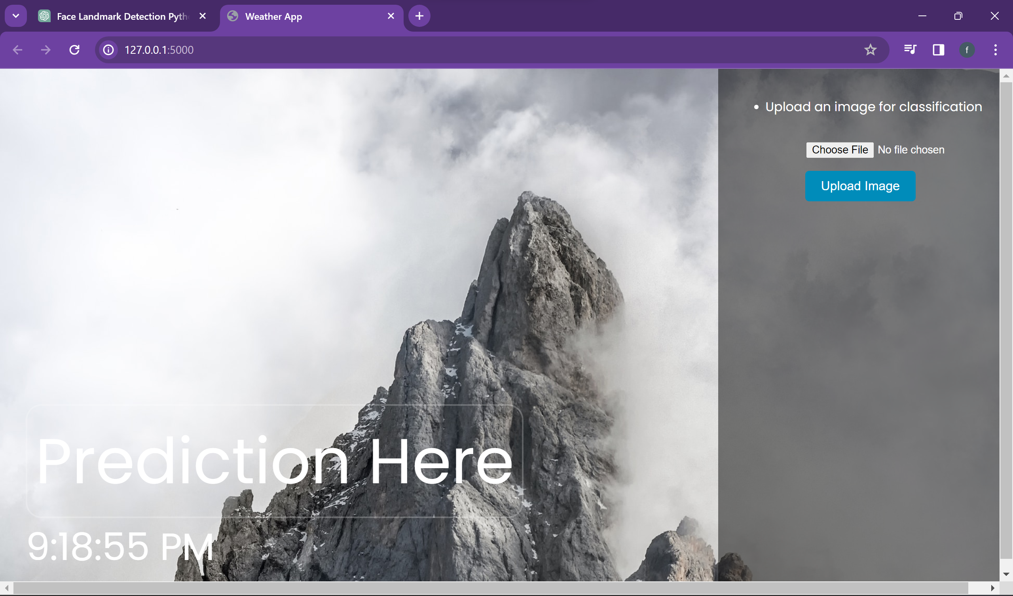
      2. 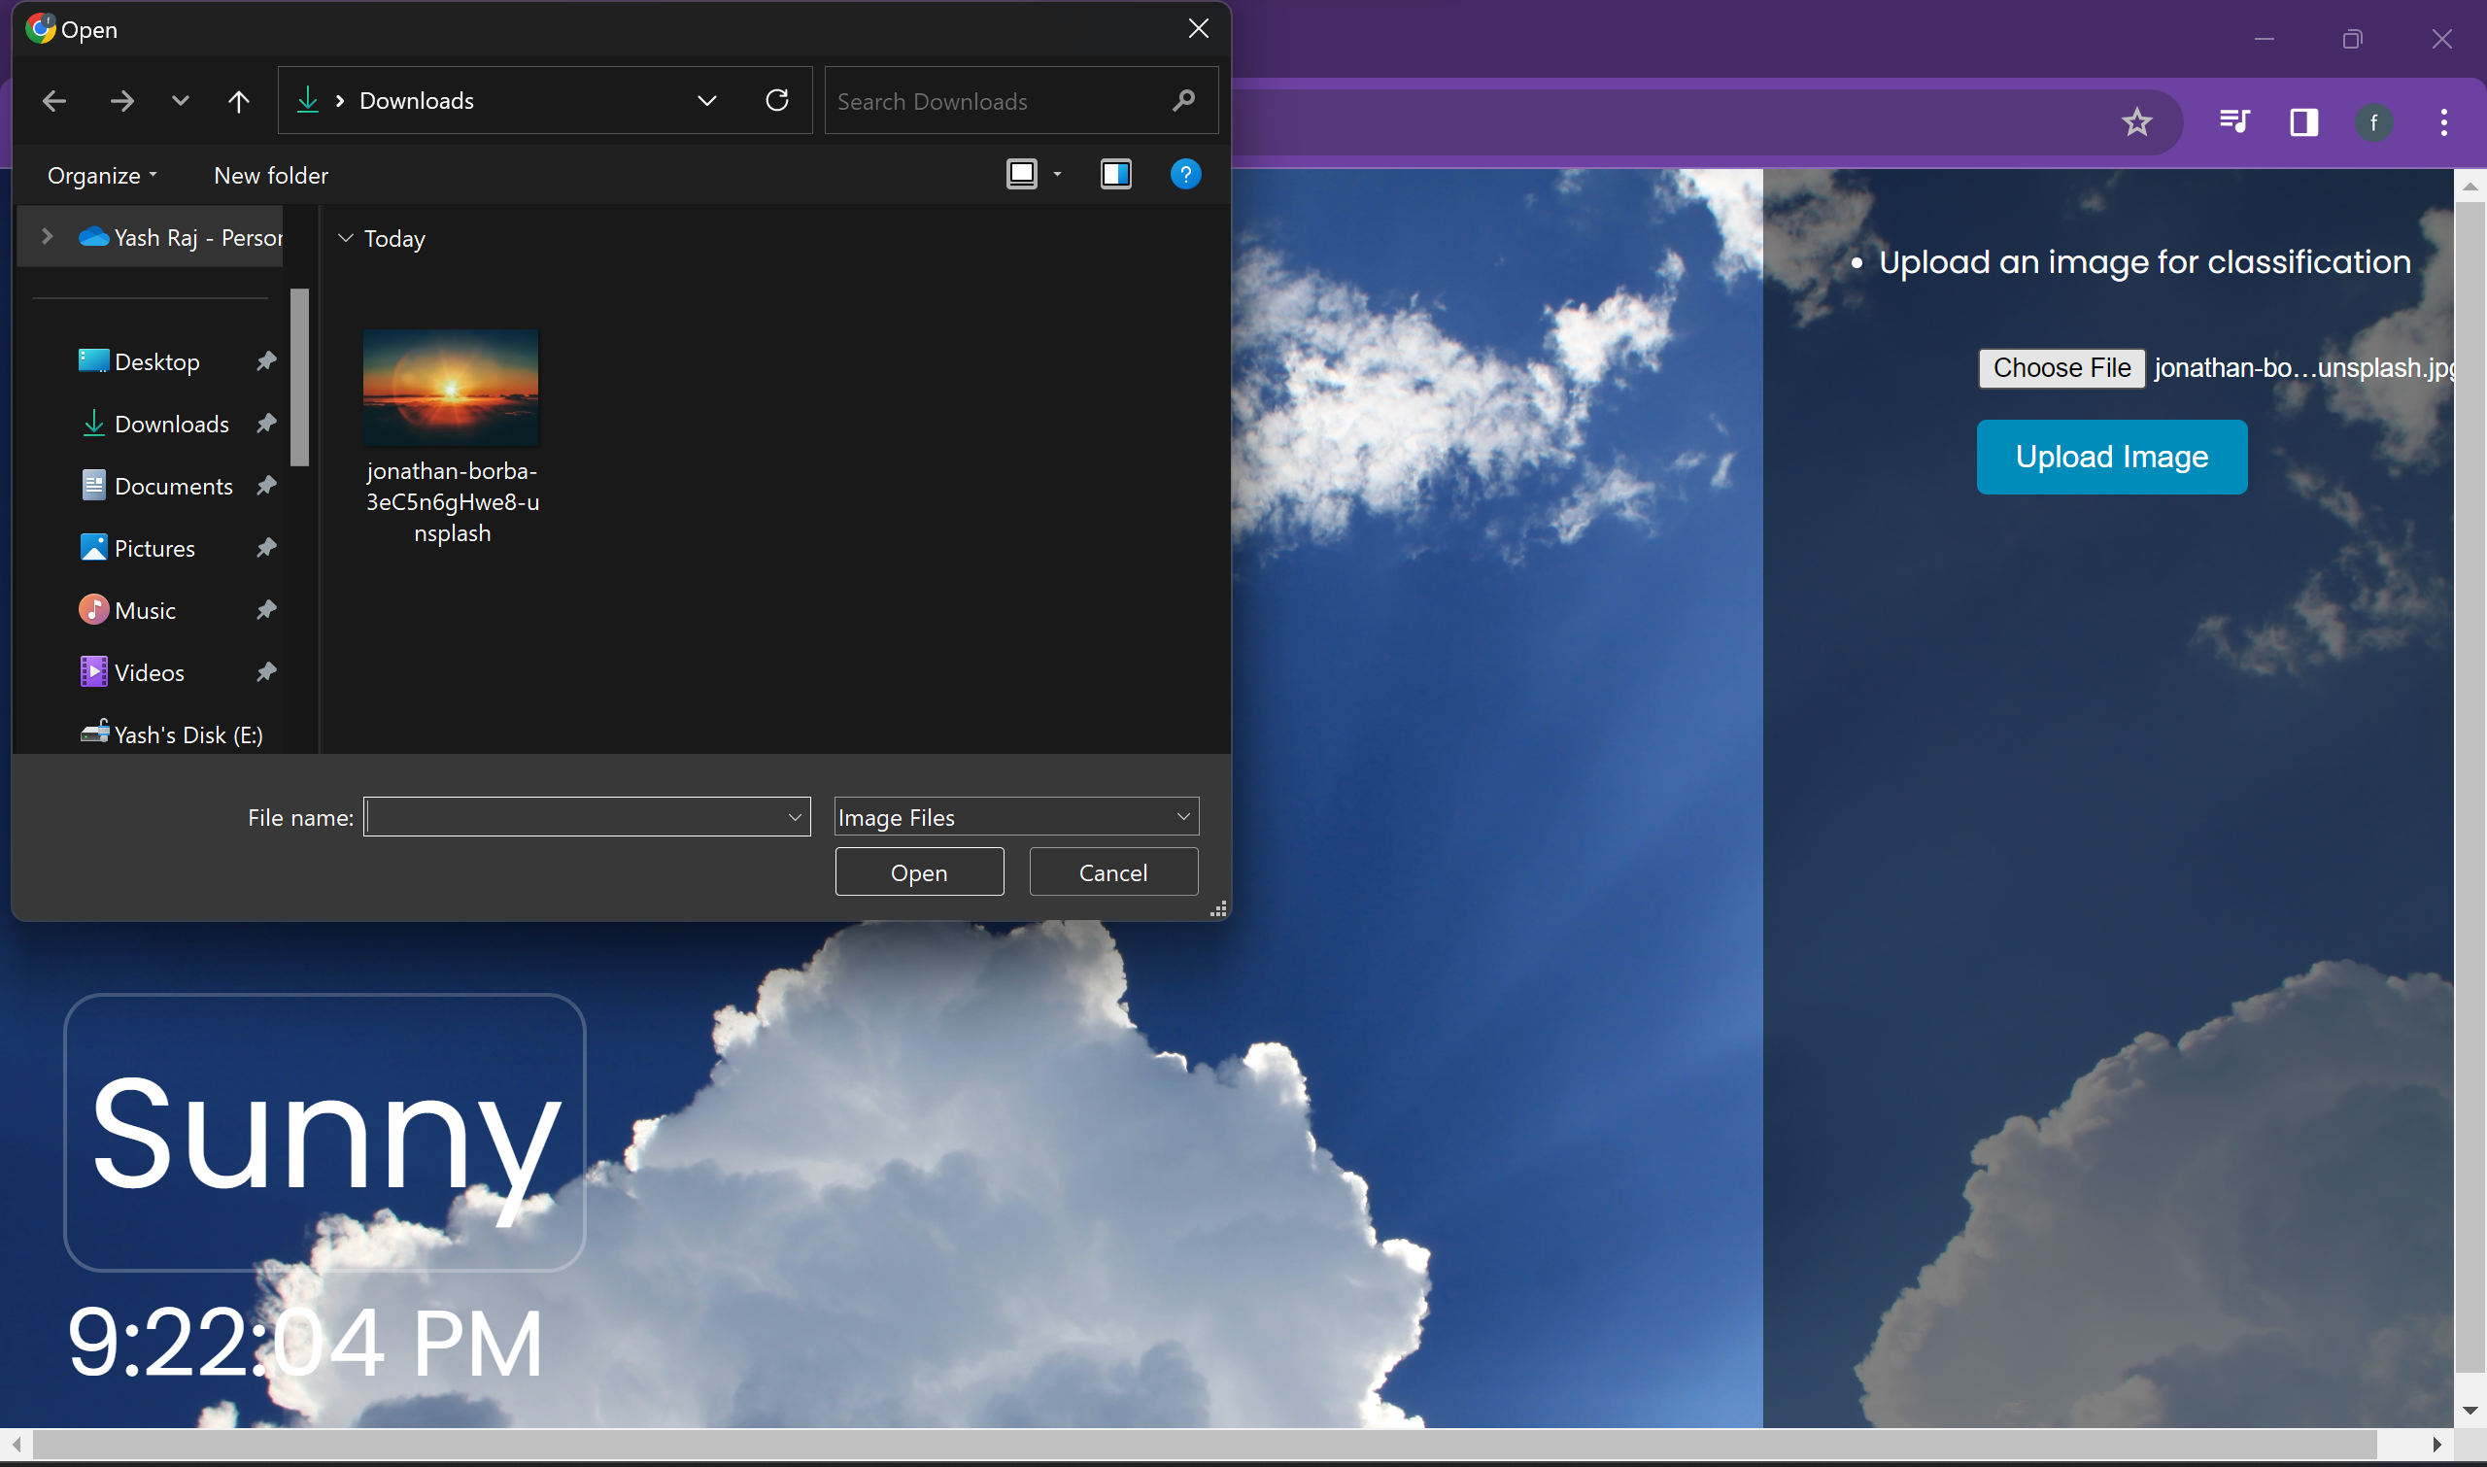
      3. 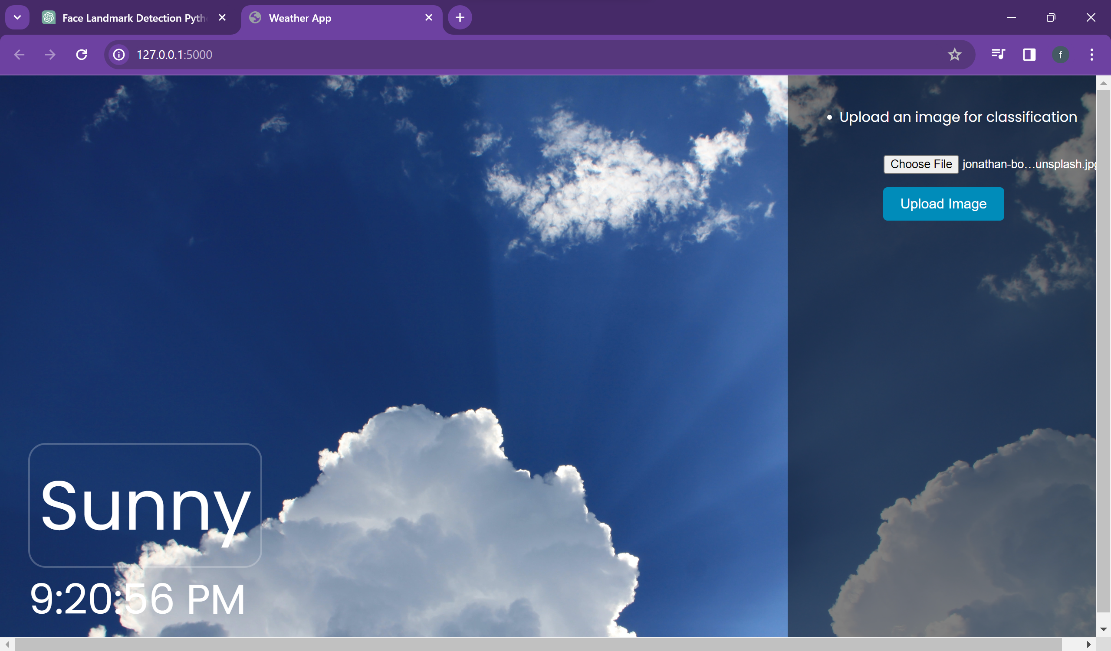
2. Advantages and Disadvantages
   1. Advantages of Weather Classification Using Deep Learning
      1. Increased Accuracy: Deep learning models, particularly those utilizing transfer learning, are capable of achieving high accuracy in classifying weather phenomena, surpassing traditional methods.
      2. Automated Analysis: The system can automatically process and analyze vast amounts of weather data, reducing the need for manual intervention and the risk of human error.
      3. Real-time Processing: Deep learning allows for the real-time analysis of weather data, enabling quicker response times for weather forecasting and warning systems.
      4. Handling Complex Patterns: These models are adept at handling complex and non-linear weather patterns, which can be challenging for traditional statistical methods.
      5. Scalability: Deep learning models can be scaled to accommodate large datasets, making them suitable for comprehensive weather analysis across various geographical locations.
      6. Adaptability: With retraining capabilities, these systems can adapt to new weather patterns and changes in environmental conditions over time.
      7. Integration with Existing Systems: They can be integrated with current weather forecasting systems to enhance their predictive capabilities.
      8. Enhanced Decision Making: Accurate weather classification aids in better decision-making in sectors like agriculture, aviation, and disaster management.
   2. Disadvantages of Weather Classification Using Deep Learning
      1. Data Dependency: The performance of deep learning models heavily relies on the quantity and quality of the training data. Insufficient or poor-quality data can lead to inaccurate classifications.
      2. Overfitting Risk: There is a risk of models becoming too tailored to the training data, making them less effective at generalizing to new, unseen data.
      3. Computational Intensity: Training deep learning models requires significant computational resources, which can be a barrier for some organizations.
      4. Expertise Required: Implementing and maintaining these systems require specialized knowledge in deep learning and data science, which can be a constraint.
      5. Model Opacity: Deep learning models, often referred to as "black boxes," can lack transparency in how they arrive at a classification, making it difficult to interpret the results.
      6. Maintenance and Updating: These systems require continuous updating and retraining to stay effective, which can be resource-intensive.
      7. Environmental Impact: The high computational demand of training and running deep learning models has a considerable energy footprint, contributing to environmental concerns.
      8. Privacy and Security: Collecting and processing weather data, especially if it includes geolocation data, raises concerns regarding data privacy and security.
3. Conclusion

The application of deep learning in weather classification represents a significant advancement in the field of meteorology and environmental monitoring. By leveraging sophisticated algorithms and the power of transfer learning, systems can classify various weather phenomena with high accuracy and efficiency. This technology has the potential to revolutionize how weather data is processed, interpreted, and used in various sectors, from agriculture to disaster management.

The automation and real-time processing capabilities of deep learning models offer a substantial improvement over traditional methods, allowing for quicker and more accurate weather predictions. This advancement is crucial in an era where weather patterns are becoming increasingly volatile due to climate change.

However, the implementation of such systems is not without challenges. The dependency on large, high-quality datasets, the need for significant computational resources, and the requirement for specialized expertise are notable hurdles. Moreover, the environmental impact of the computational demands and concerns regarding data privacy cannot be overlooked.

1. Future Scope

Looking ahead, several areas offer promising avenues for further development and improvement in weather classification using deep learning:

* Data Enhancement: Developing methods to generate or augment weather data, potentially through synthetic data generation, could alleviate the issue of data scarcity and improve model robustness.
* Model Transparency: Advancements in explainable AI could make deep learning models more transparent and interpretable, enhancing trust and usability.
* Energy Efficiency: Research into more energy-efficient model architectures and training methods could reduce the environmental impact of these systems.
* Edge Computing: Deploying models on edge devices could enable real-time, on-site weather classification, reducing reliance on centralized computational resources.
* Cross-Domain Adaptation: Adapting models for different geographic regions and climates can improve the generalizability and usefulness of the systems worldwide.

1. Appendix
   1. Github Link: **https://github.com/smartinternz02/SI-GuidedProject-599542-1697547608**
   2. Project Demo link:
      1. **https://drive.google.com/drive/folders/1rTHeLJeNVDY5Bc2AfhOuC9TGKRaUJovI?usp=sharing**